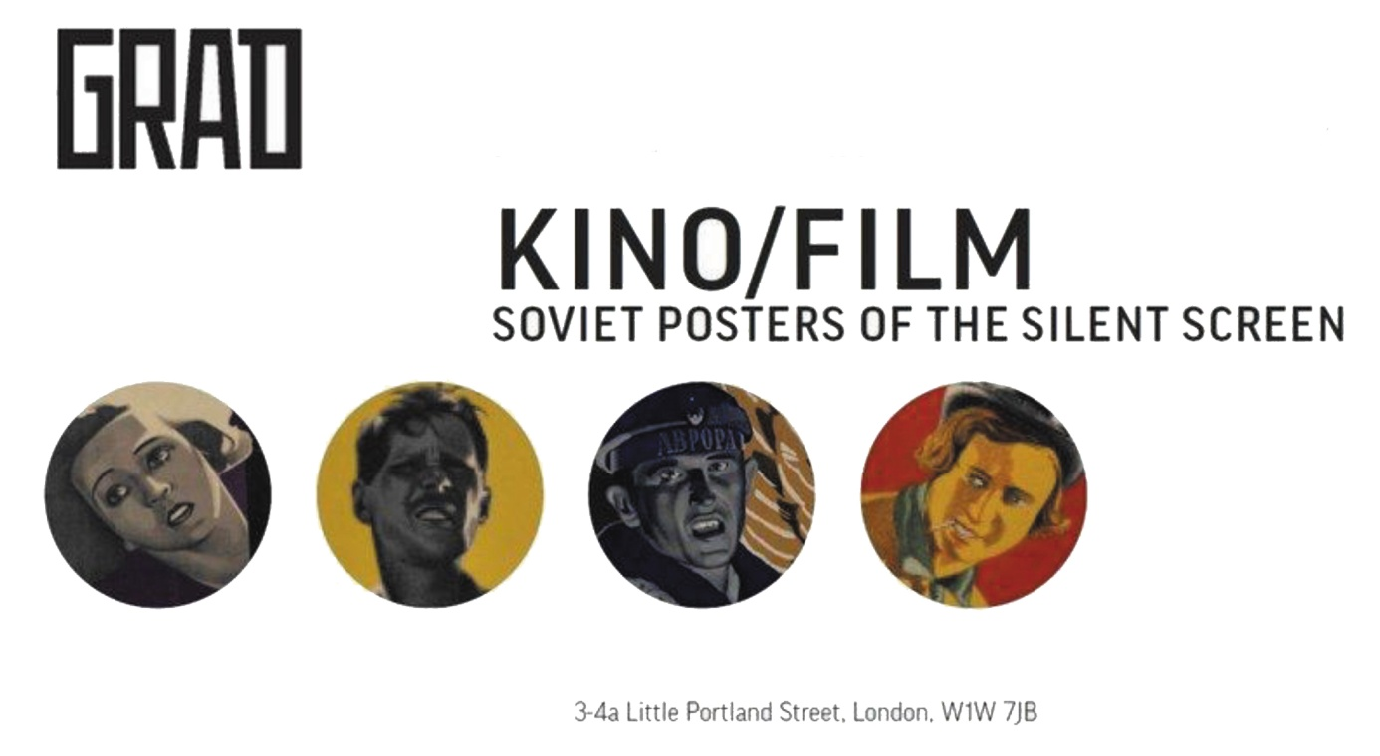

**KINO/FILM: Soviet Posters of the Silent Screen  
17 January - 29 March 2014**

GRAD: Gallery for Russian Arts and Design in collaboration with Antikbar is pleased to present KINO/FILM: Soviet Posters of the Silent Screen. As the UK-Russia Year of Culture begins, this exciting exhibition examines the golden age of Soviet film posters and is co-curated by Elena Sudakova, Director of GRAD, and film critic and art historian Lutz Becker.

The 1920s saw the advent of new and radical graphic design created to advertise silent films across the Soviet Union. Film posters of this era have become masterpieces in their own right, produced at a time when innovative on-screen techniques were being incorporated into the design of advertisements. Some 30 works by the brothers Georgii and Vladimir Stenberg, Yakov Ruklevsky, Aleksandr Naumov, Mikhail Dlugach and Nikolai Prusakov, will be on display. During the mid- to late-1920s, cinema flourished in the Soviet Union. A relatively new art form, film matched the revolutionary ethos of an emerging generation of artists for whom fine art was deemed bourgeois.

To accompany the exhibition GRAD will host screenings to showcase the innovative techniques employed by the poster artists and film-makers of this era. Excerpts of seminal films, among them *October*, *The End of St Petersburg* and *Storm Over Asia*, will highlight the symbiotic relationship between the pioneering vision of directors such as Sergei Eisenstein and Vsevolod Pudovkin and the output of the poster artists engaged to promote them. Techniques such as cinematic montage, repetition, asymmetric viewpoints and dramatic foreshortenings were used in the creation of both the films and the posters, leading to the appearance of a distinctive and highly influential body of design. Mass produced during the 1920s, the posters were made for one use only and few originals survive.

The exhibition at GRAD is a rare opportunity to see these seminal works, many of which have not been exhibited in the UK before.

**About GRAD**

GRAD is an enterprising not-for-profit gallery exhibiting Russian art in central London, including rarely seen graphic arts and other works from Russian collections, as well as specially commissioned pieces. The gallery presents exhibitions in collaboration with international co-curators, accompanied by seminars dedicated to academic and curatorial developments in Russian Art studies from the early 20th Century to the present day.

GRAD is open Tue-Fri 11am – 7pm, Sat 11am – 5pm.